Pet Project
In the period from 25.07 to 06.08: the share of premium fuel (Premium Product Line) changed in the structure relative to other product lines. (The share of Premium Product Lines increased) Based on the available data in the file, it is necessary to answer the question "why did this happen?", considering that total sales across all product lines were declining during this period.
Plan
1 Perform an exploratory analysis to validate the hypothesis
2 Identify potential factors that retain the effect
3 Gradually examine the impact of parameters on the key metric
4 Draw conclusions
5 Use the second dataset for additional exploration (this wasn’t part of the task, but could be interesting)
To demonstrate the willingness to learn new skills/tools and for general development, we will create an overview dashboard in Tableau.
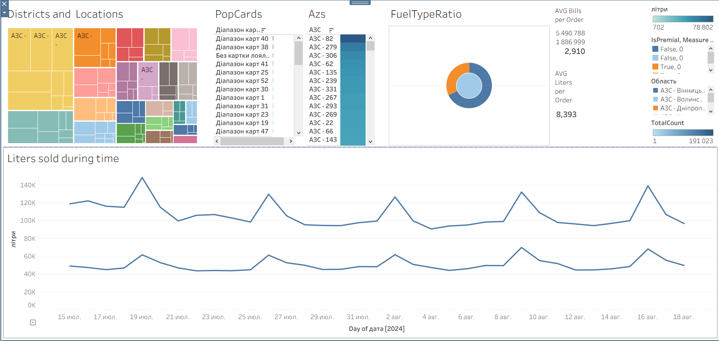
We will also confirm the task conditions.
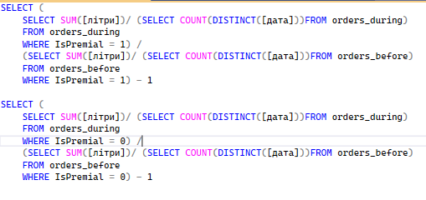
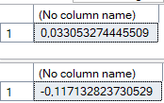
Indeed, as we can see, the premium product lines are growing slightly, despite the overall trend of a slight decline.
Method of analysis: split the data into two time-based cohorts. Examine each gas station / location / region separately. The goal is to identify gas stations / locations / regions that lost positions in regular fuel but managed to maintain an arbitrage advantage for the premium product line.
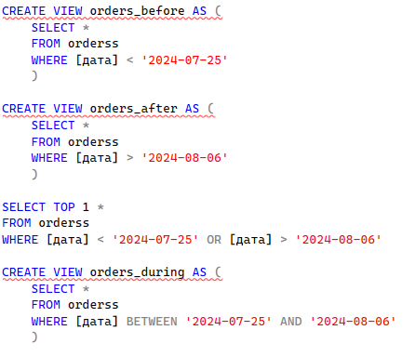
Main metric:
Liters sold in the recent period / Liters sold in the previous period – 1
Since the analyzed period consists of 13 days, while the previous dataset includes only 10 days, we will divide the result by the number of days to work with an average rather than an absolute quantity.

Let’s determine the percentage increase in premium fuel sales for each gas station.
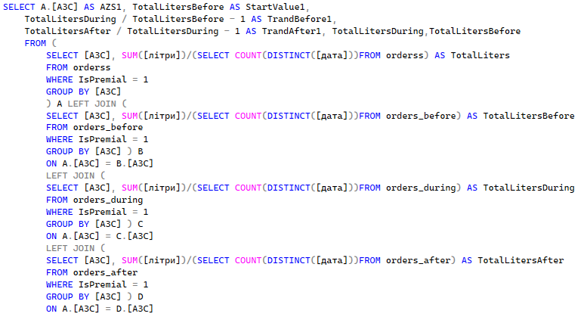
Similarly, we will calculate the growth for regular fuel. After merging the two aggregated tables by the [Gas Station] field, we will be able to directly compare the trend of premium and regular product lines.
TrandBefore1 - TrandBefore0 AS TrendBeforeDIFF
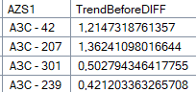

Conclusion regarding each gas station
To make an accurate conclusion, we take into account the weight of each gas station.
Crucial_Value = Premium fuel trend * Percentage of all orders
AZSRatio * (TrandBefore1 - TrandBefore0) AS FinalMetric
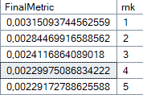
Practical significance
We will also introduce a simpler, more intuitive indicator — “how many additional liters were sold thanks to the growth of premium product lines.”
In other words: “If the negative trend had also affected premium fuel, we would have lost X liters — but this did not happen.”
Formula:
Current premium sales – Previous premium sales * (1 + Regular fuel trend)
TotalLitersDuring - TotalLitersBefore * (1+TrandBefore0)
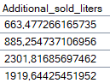

Final query
In the end, we have a query that can be extended to other factors, such as location/region/payment method.
SELECT AZS1, TrandBefore1 - TrandBefore0 AS TrendBeforeDIFF, TrandAfter1 - TrandAfter0 AS TrandAfterDIFF, AZSRatio,
AZSRatio * (TrandBefore1 - TrandBefore0) AS FinalMetric,
ROW_NUMBER() OVER (ORDER BY AZSRatio * (TrandBefore1 - TrandBefore0) DESC) AS rnk,
TotalLitersDuring - TotalLitersBefore * (1+TrandBefore0) AS Additional_sold_liters
FROM (
SELECT A.[АЗС] AS AZS1, TotalLitersBefore AS StartValue1,
TotalLitersDuring / TotalLitersBefore - 1 AS TrandBefore1,
TotalLitersAfter / TotalLitersDuring - 1 AS TrandAfter1, TotalLitersDuring,TotalLitersBefore
FROM (
SELECT [АЗС], SUM([літри]) AS TotalLiters
FROM orderss
WHERE IsPremial = 1
GROUP BY [АЗС]
) A LEFT JOIN (
SELECT [АЗС], SUM([літри]) AS TotalLitersBefore
FROM orders_before
WHERE IsPremial = 1
GROUP BY [АЗС] ) B
ON A.[АЗС] = B.[АЗС]
LEFT JOIN (
SELECT [АЗС], SUM([літри]) AS TotalLitersDuring
FROM orders_during
WHERE IsPremial = 1
GROUP BY [АЗС] ) C
ON A.[АЗС] = C.[АЗС]
LEFT JOIN (
SELECT [АЗС], SUM([літри]) AS TotalLitersAfter
FROM orders_after
WHERE IsPremial = 1
GROUP BY [АЗС] ) D
ON A.[АЗС] = D.[АЗС]
) A FULL JOIN (
SELECT A.[АЗС] AS AZS0 , TotalLitersBefore AS StartValue0, TotalLitersDuring / TotalLitersBefore - 1 AS TrandBefore0, TotalLitersAfter / TotalLitersDuring - 1 AS TrandAfter0
FROM (
SELECT [АЗС], SUM([літри]) AS TotalLiters
FROM orderss
WHERE IsPremial = 0
GROUP BY [АЗС]
) A LEFT JOIN (
SELECT [АЗС], SUM([літри]) AS TotalLitersBefore
FROM orders_before
WHERE IsPremial = 0
GROUP BY [АЗС] ) B
ON A.[АЗС] = B.[АЗС]
LEFT JOIN (
SELECT [АЗС], SUM([літри]) AS TotalLitersDuring
FROM orders_during
WHERE IsPremial = 0
GROUP BY [АЗС] ) C
ON A.[АЗС] = C.[АЗС]
LEFT JOIN (
SELECT [АЗС], SUM([літри]) AS TotalLitersAfter
FROM orders_after
WHERE IsPremial = 0
GROUP BY [АЗС] ) D
ON A.[АЗС] = D.[АЗС]
) B
ON A.AZS1 = B.AZS0
FULL JOIN (SELECT [АЗС] AS AZS, CAST(COUNT(*) AS FLOAT) / (SELECT COUNT(*) FROM orderss) AS AZSRatio FROM orderss GROUP BY [АЗС]) C
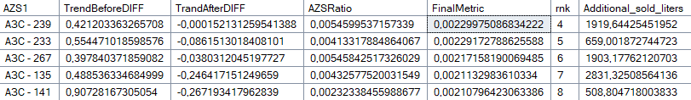
ON A.AZS1 = C.AZS;

Notes and validation
We will remove the most important parameters and observe how the premium product line behaves. A shift toward the general declining trend in the absence of these criteria will indicate their influence on sales.
Placement Type : ТаможенныйПереход
Location in Settlement : 'На трасі', 'Місто'
Region : Івано-Франківськ
Card Range: 38,41,40
Sales Type: Гаманець
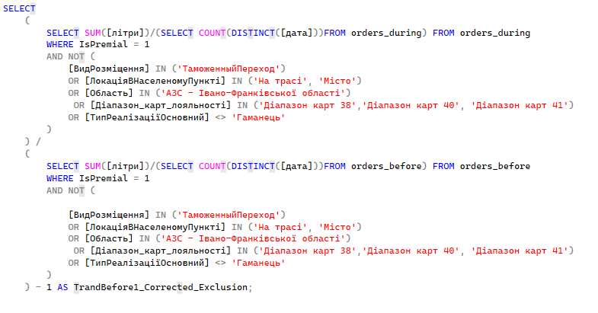
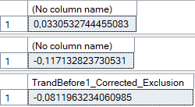 The premium fuel after changea
The biggest effect comes from Pride cards. Without them, there is a drop of 20 points (0.03 → 0.01). Payment type also plays an important role – 20 points. Location – 15, region – 5, placement type – 3.
Conclusion
These results provide food for thought. Although it is difficult to make precise statements without additional data, some assumptions can be made.
The premium fuel trend remains unchanged.
The regular fuel trend remains unchanged
A well-targeted campaign aimed at specific consumer groups (Pride cards 38, 40, 41) positively influenced the overall premium product sales. An interesting observation: if we exclude buyers without a loyalty card from the dataset, the share of premium fuel increases, indicating that this type of product is particularly popular among registered customers.
At first glance, cash is associated with quick purchases without focusing on high quality. Hypothetically, this could be due to premium fuel purchases by logistics using unofficial cash flows.
It is also likely that people are more willing to buy fuel after receiving their salary. The premium segment, however, is less dependent on this and is not tied to specific dates.
ADDITIONAL RESEARCH BELOW

Additionally
It became interesting whether the second dataset could be used for the analysis. Since the product lines are not labeled and there is no match by relative share, comparing sales trends directly is not possible. However, if we assume that by the 10th month the premium fuel / regular fuel trend had stabilized, we can additionally examine which factors influenced trade volumes.
Algorithm:
- Isolate criteria (specific gas stations, locations, regions) that are more oriented toward premium fuel
- If their performance decreases over time (recall that we assumed a general decline in premium fuel), this will serve as evidence of their influence
- Similarly, the share of criteria more oriented toward regular fuel should increase
We will again illustrate this using the example of a gas station.
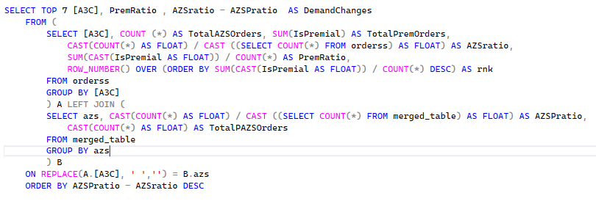
After the transformations, we derived 2 key metrics for each gas station:
- how many gas stations sell specifically premium product lines
- how much the overall sales volume has increased or decreased
Now it remains to normalize the metrics and insert them into the weighted formula.
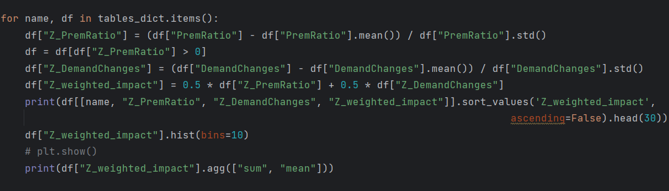

Here, filtering is first applied by Z_prem_ratio, meaning we focus on gas stations with an emphasis on premium fuel.
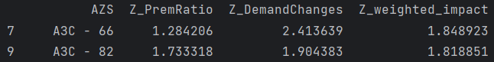
As we can see, all gas stations that focused on premium product lines dominated in months 7–8. Conversely, gas stations oriented toward regular fuel had an advantage in October.
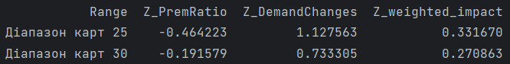
This approach helps to examine all anomalies and patterns more thoroughly. Research on other factors can be found in the Python code.
The second additional study is based on forecasting the share of premium product lines.
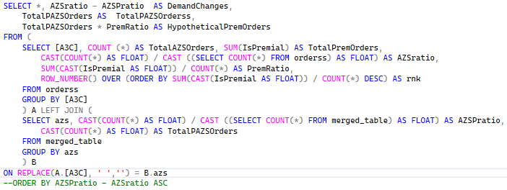
We can compare the share of premium fuel in months 7–8 with month 10 (assuming that over time the gas stations did not start selling fuel in a different proportion).
In other words, we examine how changes in trade volumes affect the share of premium fuel. Example: if “Store 1” sells 90% premium products and accounts for 50% of the total market, then its decline would explain the previous success of the premium product line.
Let’s calculate that same percentage.



We observe a shift of 1%, which can be considered a relatively significant change. Similar analyses with other variables are available in the script file.

Percentage of premium fuel
New percentage of premium fuel

